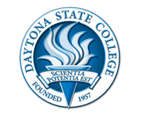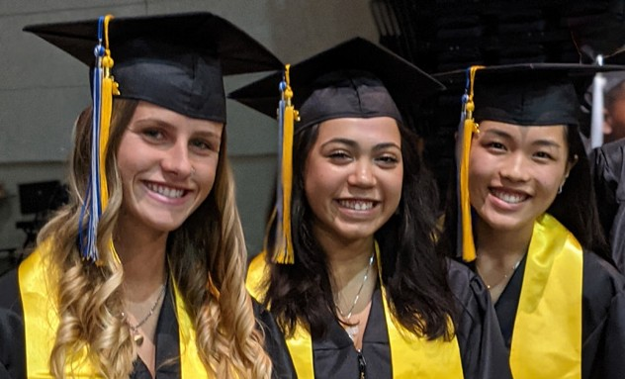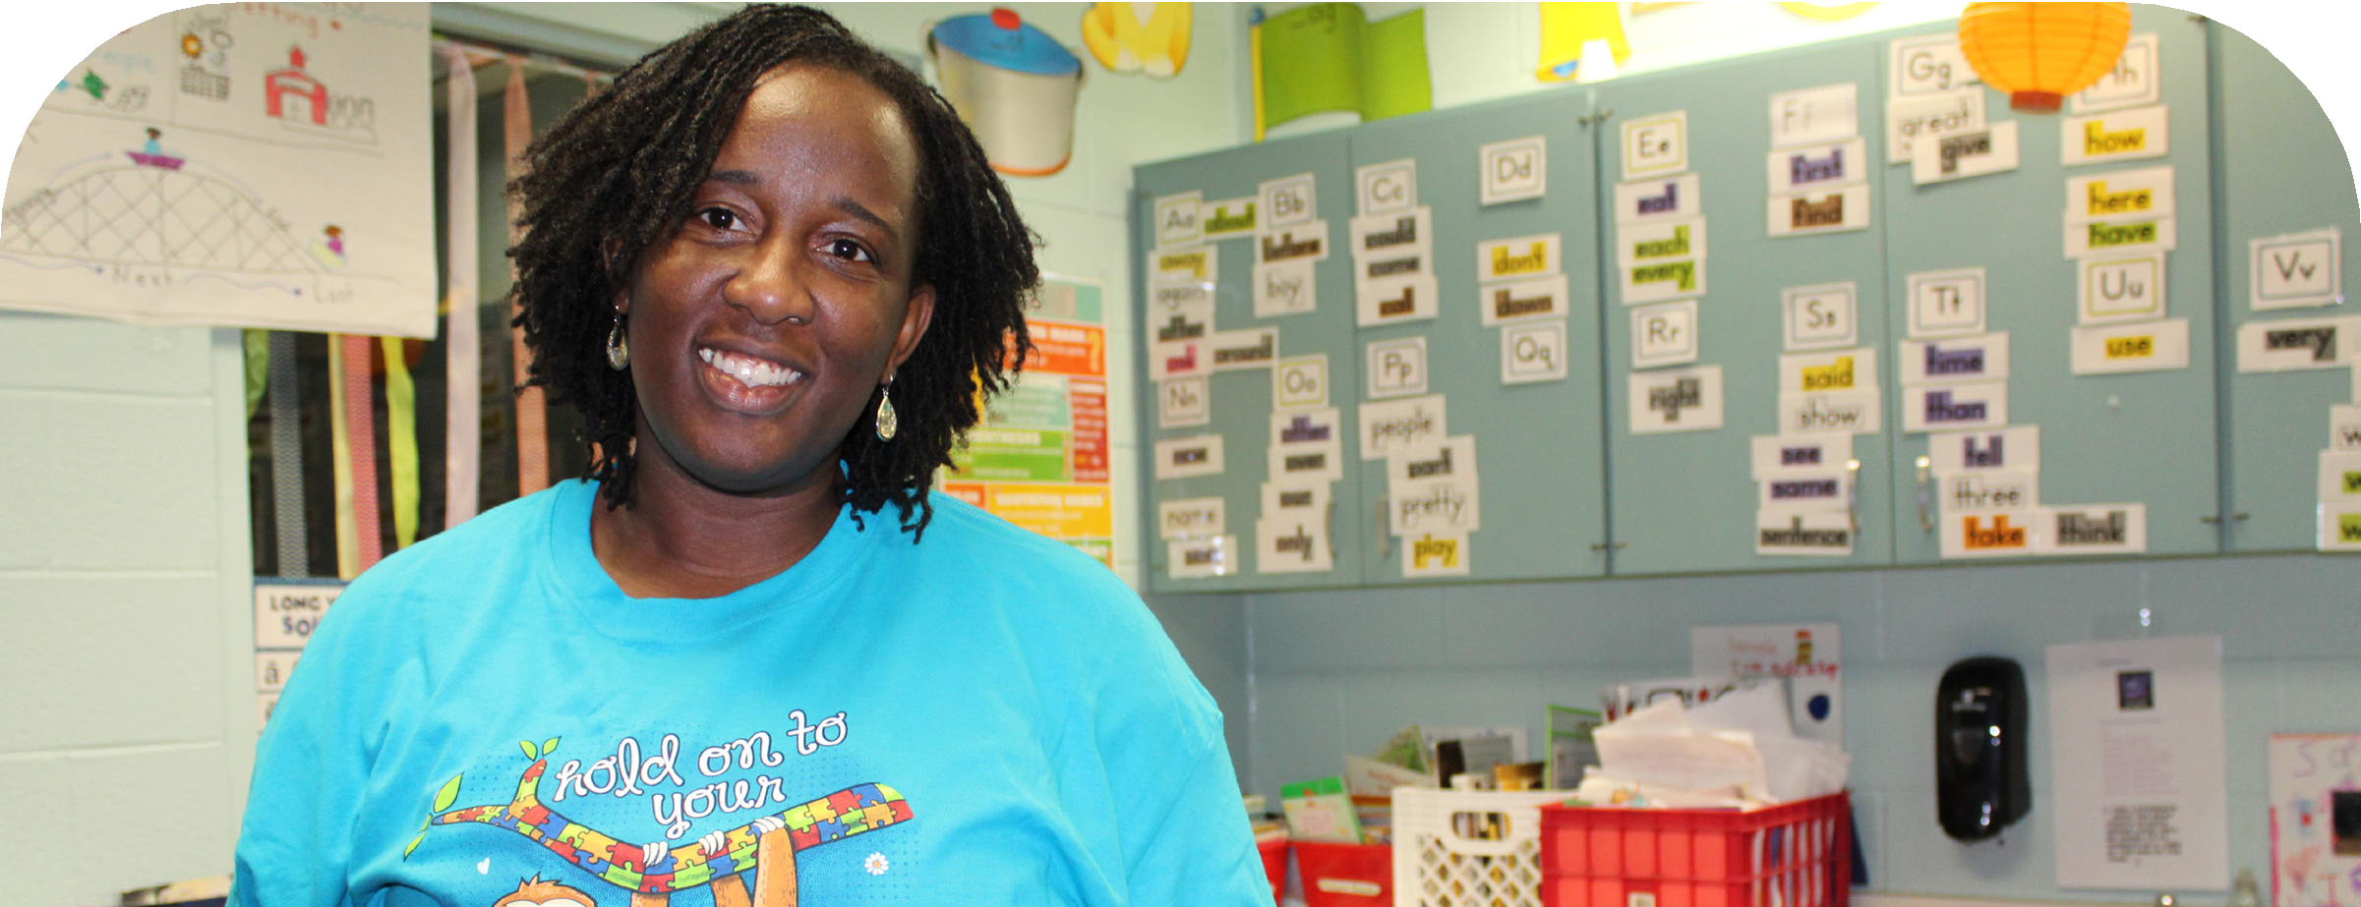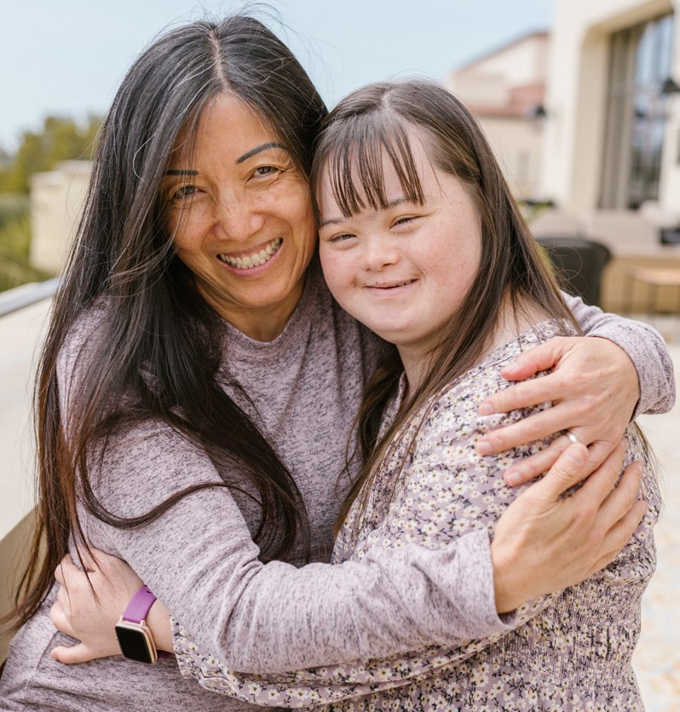

Para to ESE Teacher Program

DAYTONA STATE COLLEGE - SCHOOL OF EDUCATION
Now offering a Florida state-approved bachelor’s program for full-time paraprofessionals in public schools!
Courses are offered online and in the evenings. Graduates earn a Bachelors in Exceptional Student Education and their full Reading and ESOL Endorsement.

For more information regarding scholarships and funding:
- The Florida Para-to-Teacher Tuition Support for Exceptional Student Educators
- The Daytona State Foundation Scholarship
- Florida Fund for Minority Teachers (more info DSC FFMT Scholarship Informational Video)

Application for Admissions

Contact the School of Education:

Camille Wasick Sr. Staff Assistant 386-506-3770
Camille.Wasick@DaytonaState.edu
Martin Goldys
Student Tracking Coordinator 386-506-3464
Martin.Goldys@DaytonaState.edu
Dr. Donald May Academic Chair 386-506-3442
Donald.May@DaytonaState.edu

260629A_035 6/22

